Dimitri Tabagari

823 356 359

February 29, 2020

Platypus

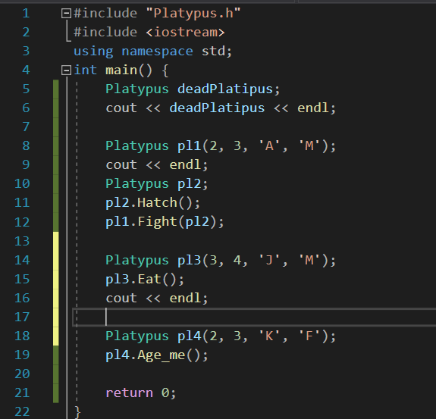

* Line 4 – Creating platypus with default constructor

Line 5 – Printing contents of dead platypus

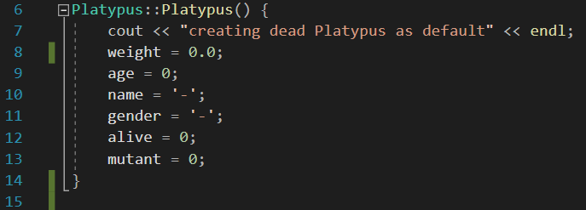

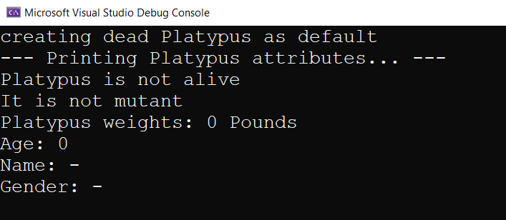

* Line 8 – Creating Platypus

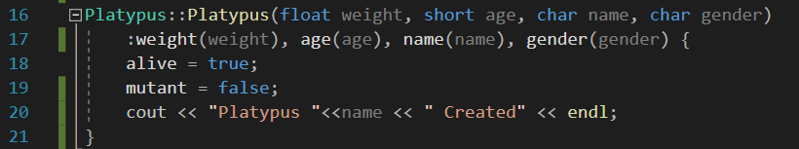



* Line 10&11– Creating dead platypus and Hatching it so it is alive (also give it random sex and char name)

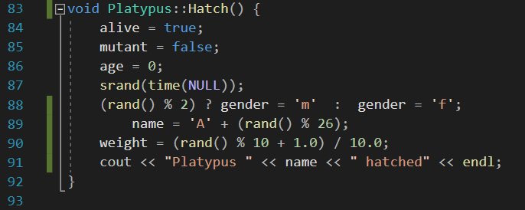

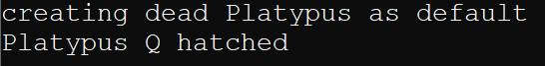

* Line 12 – Fight Platypus pl1 and pl2 and see which dies

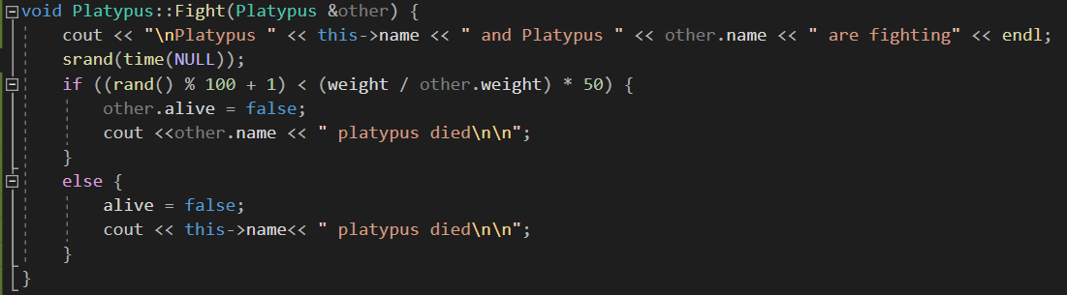

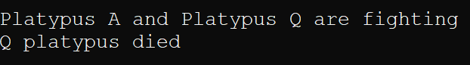

* Line 14 – Creating pl3

Line 15 – feed pl3 and see if he dies or not

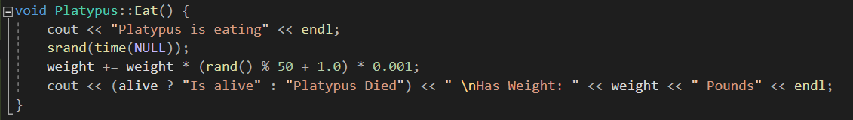

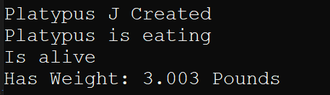

* Line 18 – create pl4

Line 19 – Age pl4 and see if it dies or turns into mutant

